- Download BLE Debugger in Android Phone.
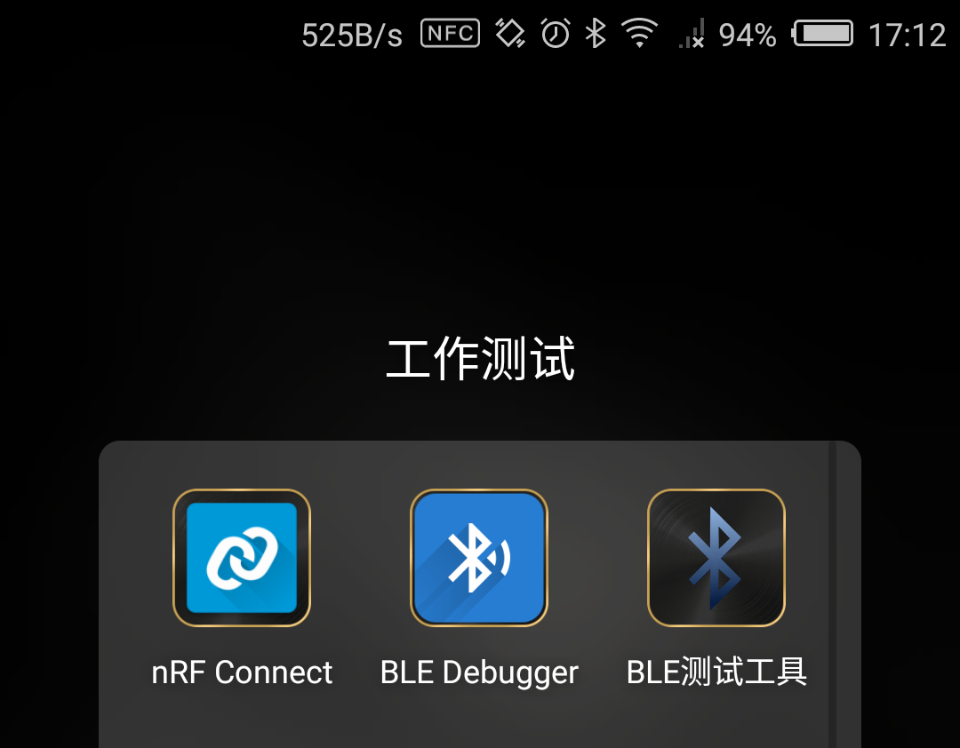

- Connect BLE of camera, Then connect to service in the APP.
Click Link Loss and send command
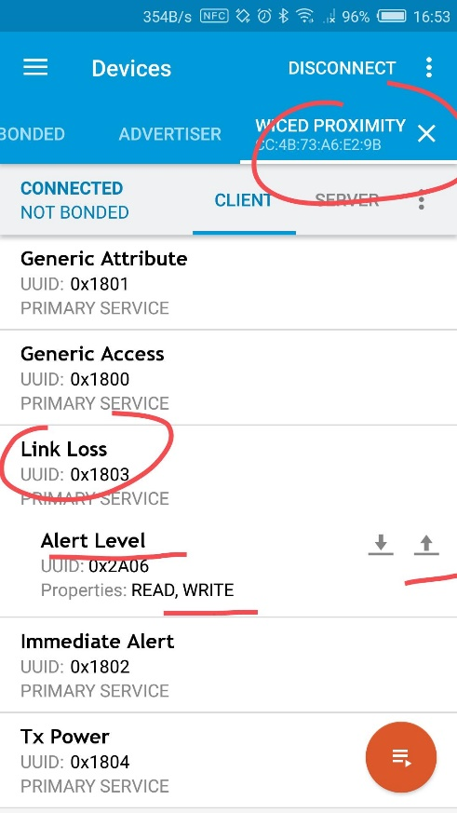

- Below is the command list.
For example 0x00 is for start recording function.

enum _USER_EVENT
{
USER_STARTREC_EVENT,//record video //0
USER_STOPREC_EVENT,//stop video //1
USER_PHOTO_EVENT,//take photo //2
USER_WIFI_EVENT,//turn on/off wifi //3
USER_PWOFF_EVENT,//power off //4
USER_DISC_DEV_EVENT,//Discovery equipment //5
USER_EVENT_ID_MAX
};

